24th Annual Process Safety International Symposium
October 19-21, 2021 | College Station, Texas

Title

Author Names
Company or Organization
City Address (optional)
*Presenter E-mail or Presenters E-mails: email address, email address

Abstract

Abstract Body Abstract Body Abstract Body Abstract Body Abstract Body Abstract Body Abstract Body Abstract Body Abstract Body Abstract Body Abstract Body Abstract Body Abstract Body Abstract Body Abstract Body Abstract Body Abstract Body Abstract Body Abstract Body Abstract

Keywords:

Introduction
Introduction Introduction Introduction Introduction Introduction Introduction Introduction Introduction Introduction Introduction Introduction Introduction Introduction Introduction Introduction Introduction Introduction Introduction Introduction Introduction Introduction Introduction Introduction Introduction [1].

Methodology
Methodology Methodology Methodology Methodology Methodology Methodology Methodology Methodology Methodology Methodology Methodology Methodology Methodology Methodology Methodology Methodology Methodology Methodology Methodology Methodology Methodology Methodology Methodology Methodology Methodology Methodology [2,3].

Analysis
Analysis Analysis Analysis Analysis Analysis Analysis Analysis Analysis Analysis Analysis Analysis Analysis Analysis Analysis Analysis Analysis Analysis Analysis Analysis Analysis Analysis Analysis Analysis Analysis Analysis Analysis Analysis Analysis Analysis [4].

Results
Results Results Results Results Results Results Results Results Results Results Results Results Results Results Results Results Results Results Results Results Results Results Results Results Results Results Results Results Results Results Results Results

4.1 More Results
More results More results More results More results More results More results More results More results More results More results More results More results More results More results More results More results More results
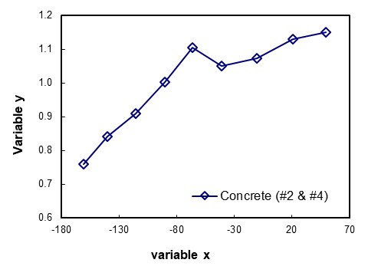
Figure 1: figure figure figure
4.2 More Results
More results More results More results More results More results More results More results More results More results More results More results More results More results More results More results More results More results

Conclusions
Conclusion Conclusion Conclusion Conclusion Conclusion Conclusion Conclusion Conclusion Conclusion Conclusion Conclusion Conclusion Conclusion Conclusion Conclusion Conclusion Conclusion Conclusion Conclusion Conclusion Conclusion Conclusion Conclusion Conclusion Conclusion Conclusion

References
[1] D. Crowl, and J.F. Louvar, Chemical Process Safety: Fundamentals with Applications, 3rd ed., Pearson Education, Boston, Massachussetts, 2011.
[2] W. R. Chapman and R. V. J. J. o. t. C. S. Wheeler, "VI.—The propagation of flame in mixtures of methane and air. Part V. The movement of the medium in which the flame travels," pp. 38-46, 1927.
[3] I. O. Moen, "Transition to detonation in fuel-air explosive clouds," Journal of Hazardous Materials, vol. 33, no. 2, pp. 159-192, 2// 1993, doi: http://dx.doi.org/10.1016/0304- 3894(93)85052-G.
[4] A. J. Pierorazio, J. K. Thomas, Q. A. Baker, and D. E. Ketchum, "An update to the Baker-Strehlow-Tang vapor cloud explosion prediction methodology flame speed table," Process Safety Progress, vol. 24, no. 1, pp. 59-65, 2005, doi: 10.1002/prs.10048.

